WEBR Tracing Configuration

**Page.Config:**

Necessary changes are needed in the page.config to properly enable the PG&E tracing functionality. The below is an example of the new section that must added to the page.config and modified to suit the business needs.

The new <PGETraces> element specified below should be added in the <Tracing> element.

**ClassIDToLayerIDMap:** This section can be used to define the ClassID to LayerID mapping for different ArcGIS services. This provides the benefit of removing the necessity to build this mapping on the initial trace for a user in the WEBR environment. It does add much more manual maintenance when any changes are made to published Mxds.

**PGEProtectiveDevices**: This section defines the protective devices that should be returned when an upstream or downstream protective device trace is executed.  
 Name: Identifier for the protective device.  
 ClassID: Feature class ID for the feature class being specified.  
 SchemClassID: Feature class ID for the associated schematics feature class (if it exists).

**PGEDefaultVisibleClasses**: This section defines the feature classes that should be visible by default in the trace results. Other feature classes will not be in the trace results, but can be turned on and off by the users.  
 Name: Identifier for the protective device.  
 ClassID: Feature class ID for the feature class being specified.  
 SchemClassID: Feature class ID for the associated schematics feature class (if it exists).

**PGELoadingInformation**: This section defines the information that is necessary for the loading information dialogue which provides customer counts, KVA, and KW information.  
 TracingTableURL: Map service URL which contains all of the network feature classes, tracing tables, and related table information.  
 LayerID: Layer ID for the electric tracing table.  
**LoadingInformation**: The sub element of the PGELoadingInformation contains additional layer ID and feature class ID information that is required to obtain information for the loading information.  
 TransformerLoadLayerID: Layer ID for the transformer load table.  
 ServicePointLayerID: Layer ID for the service point table.  
 ServiceLocationFCID: Feature class ID for the service location feature class.  
 TransformerFCID: Feature class ID for the transformer feature class.  
 PrimaryGenerationFCID: Feature class ID for the primary generation feature class.  
 SecondaryGenerationFCID: Feature class ID for the secondary generation feature class.  
 TransformerUnitLayerID: Layer ID for the transformer unit table.  
**PGEElectricTraces**: This section defines the URLs that can have an electric trace executed on it.  
 TracingTableURL: Map service URL which contains all of the network feature classes, tracing tables, and related table information.  
 LayerID: Layer ID for the electric tracing table *or* the layer ID for the feeder fed network table.  
**PGEElectricTrace**: This sub element of the PGEElectricTraces element specifies a single URL that can have electric traces executed on it.  
 Url: Map service URL that can have an electric trace run against it.  
**PGESubstationTraces**: This section defines the URLs that can have a substation trace executed on it.  
 TracingTableURL: Map service URL which contains all of the network feature classes, tracing tables, and related table information.  
 LayerID: Layer ID for the substation tracing table *or* the layer ID for the feeder fed network table.  
**PGESubstationTrace**: This sub element of the PGESubstationTraces element specifies a single URL that can have electric traces executed on it.  
 Url: Map service URL that can have an electric trace run against it.  
**PGESchematicsTraces**: This section defines the URLs that can have a schematics trace executed on it.  
 TracingTableURL: Map service URL which contains all of the network feature classes, tracing tables, and related table information.  
 LayerID: Layer ID for the electric tracing table *or* the layer ID for the feeder fed network table.  
**PGESchematicsTrace**: This sub element of the PGESchematicsTraces element specifies a single URL that can have electric traces executed on it.  
 Url: Map service URL that can have an electric trace run against it.

<Tracing>

<ClassIDToLayerIDMap>

<Url value="http://edgiswebdev01:6080/arcgis/rest/services/Data/Publication/MapServer">

<Class Name="" ClassID="3524" LayerIDs="1"/>

</Url>

</ClassIDToLayerIDMap>

<PGETraces>

<PGEProtectiveDevices>

<ProtectiveDevice Name="Circuit Point" ClassID="997" SchemClassID="3207"/>

<ProtectiveDevice Name="Dynamic Protective Device" ClassID="998" SchemClassID="3210"/>

<ProtectiveDevice Name="Switch" ClassID="1005" SchemClassID="3202"/>

<ProtectiveDevice Name="Fuse" ClassID="1003" SchemClassID="2908"/>

<ProtectiveDevice Name="SUB Electric Stitch Point" ClassID="1685" SchemClassID=""/>

<ProtectiveDevice Name="SUB Switch" ClassID="1684" SchemClassID=""/>

<ProtectiveDevice Name="SUB Fuse" ClassID="1681" SchemClassID=""/>

</PGEProtectiveDevices>

<PGEDefaultVisibleClasses>

<Class Name="Circuit Point" ClassID="997" SchemClassID="3207"/>

<Class Name="Dynamic Protective Device" ClassID="998" SchemClassID="3210"/>

<Class Name="Switch" ClassID="1005" SchemClassID="3202"/>

<Class Name="Fuse" ClassID="1003" SchemClassID="2908"/>

<Class Name="Voltage Regulator" ClassID="1000" SchemClassID="3215"/>

<Class Name="Capacitor Bank" ClassID="1008" SchemClassID="3222"/>

<Class Name="Open Point" ClassID="1010" SchemClassID="3211"/>

<Class Name="SUB Electric Stitch Point" ClassID="1685" SchemClassID=""/>

<Class Name="SUB Switch" ClassID="1684" SchemClassID=""/>

<Class Name="SUB Fuse" ClassID="1681" SchemClassID=""/>

<Class Name="SUB Voltage Regulator" ClassID="1680" SchemClassID=""/>

<Class Name="SUB Capacitor Bank" ClassID="1683" SchemClassID=""/>

</PGEDefaultVisibleClasses>

<!-- The URL for loading information should be ONLY the cached electric taces table. NOT the feeder fed trace table-->

<PGELoadingInformation TracingTableURL ="http://wsgo496902:6080/arcgis/rest/services/Data/Publication/MapServer" LayerID="85">

<LoadingInformation TransformerLoadLayerID="90" ServicePointLayerID="88" ServiceLocationFCID="1012" TransformerFCID="1001" PrimaryGenerationFCID="1013" SecondaryGenerationFCID="1015" TransformerUnitLayerID="89"/>

</PGELoadingInformation>

<PGEElectricTraces TracingTableURL="http://wsgo496902:6080/arcgis/rest/services/Data/Publication/MapServer" LayerID="86">

<PGEElectricTrace Url="http://wsgo496902:6080/arcgis/rest/services/Data/ElectricDistribution/MapServer"/>

<PGEElectricTrace Url="http://wsgo496902:6080/arcgis/rest/services/Data/EDMaster/MapServer"/>

<PGEElectricTrace Url="http://wsgo496902:6080/arcgis/rest/services/Data/CircuitMap/MapServer"/>

</PGEElectricTraces>

<PGESubstationTraces TracingTableURL="http://wsgo496902:6080/arcgis/rest/services/Data/Publication/MapServer" LayerID="86">

<PGESubstationTrace Url="http://wsgo496902:6080/arcgis/rest/services/Data/Substation/MapServer"/>

</PGESubstationTraces>

<PGESchematicsTraces>

<PGESchematicsTrace Url="http://wsgo496902:6080/arcgis/rest/services/Data/Schematics/MapServer"/>

</PGESchematicsTraces>

</PGETraces>

</Tracing>

**ArcGIS Server Changes:**

A new ArcGIS service is necessary to support the PG&E tracing functionality. This will be a new Mxd that must have all of the Electric Distribution Network features, substation geometric network features, schematics “Circuit Map” layer (which should contain all schematics electric data), Transformer Load table, service point table, and transformer unit tables. This Mxd must be published with a maximum number of records returned by the server set to 100000. And ArcFMMapServer capability should be enabled under the Capabilities tab.

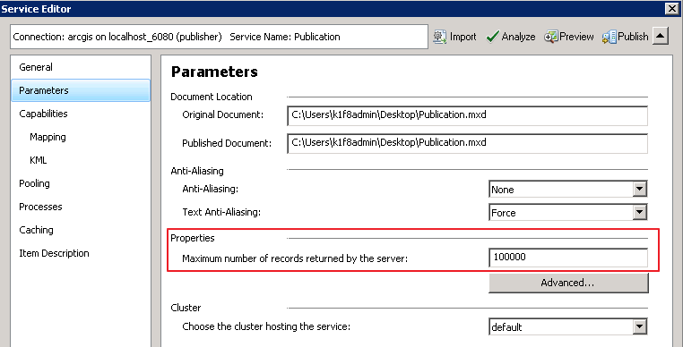

**Using WEBR Tracing:**

Once all the configuration above has been implemented the tracing and loading information the functionality in WEBR can be utilized.  
  
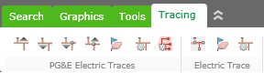

The PG&E Electric Traces has several commands available.

PG&E Upstream Device Trace  
  
PG&E Downstream Device Trace  
  
PG&E Downstream Protective Device Trace  
  
  
PG&E Upstream Protective Device Trace  
  
PG&E Clear Results  
  
Tracing Options  
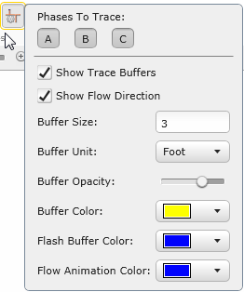  
Show Trace Results  
  
  
To perform a trace.  
1) First set all desired options in the Tracing Options menu.  
2) Select desired trace from the tracing menu.  
3) Click the desired start location on the map.  
4) For the first trace on a given stored display the tracing functionality must initialize information. A progress indicator can be viewed in the bottom left.  
  
5) Once tracing finishes, the trace results will be visible in a list on the left of the screen. These results can have different feature classes turned on and off by manually checking the desired feature classes.  
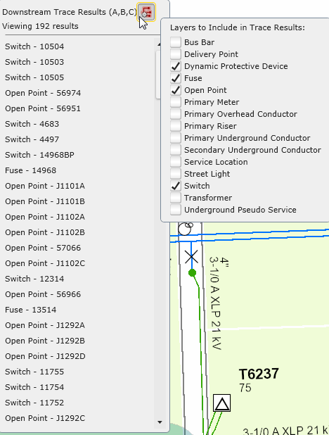  
  
Results will also be visible on the map via a buffer on the features in the results as well as a directional animation symbol indicating the power flow direction.  
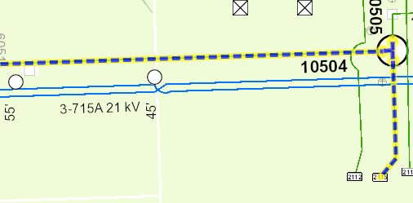  
  
Certain right click functionality is also available via the trace results window.  
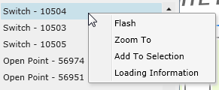  
 a) Flash: Flash the feature on the map to identify it.  
 b) Zoom To: Zoom to the feature on the map.  
 c) Add to Selection: Add the feature to the attributes viewer control.  
 d) Loading Information: Provides Loading information downstream of the selected feature.  
 